SARAPP
Search and Rate Application
Of Food Places in UP Diliman

Submitted to:

Prof. Ma. Rowena C. Solamo
Faculty Member
Department of Computer Science
College of Engineering
University of the Philippines, Diliman

Submitted by:
Angelika Galang
Julian Troy Valdez
Richelle Yap

In partial fulfillment of Academic Requirements
for the course
CS 191 Software Engineering I
of the
1st Semester, AY 2017-2018

Unique Reference:
The documents are stored in the github.com/jcvaldez1/CS191_G1_17-18_SARAPP

Document Purpose:
This document serves as the official project description document for SARAPP mobile search and rate application. This contains the overview of the whole application, its’ basic entities and relationships, and the context diagram.

Target Audience:
This document serves as a partial fulfillment of academic requirements for the CS 191 Software Engineering course, handled by Ma'am Rowena Solamo, to whom this document is made for.

Revision Control:
Revision Date | Person Responsible | Version  Number | Modification
09/04/17 | Richelle Yap | 1.0 | Created the document.

Project Title: SARAPP

Description: SARAPP is a mobile application that allows students to rate and search for food places around University of the Philippines Diliman. This application helps students look and discover food places that match their needs according to budget, location, ambiance, and food quality. This also allows food place owners to see the ratings to deliver to the customers’ needs.

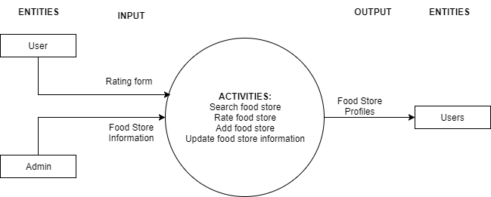
Context Diagram:

Entities:

- Users
Anyone who have downloaded the mobile application on their phones and uses it to search and rate food places in UP Diliman.
- Admin
The developers of the mobile application.

Major Inputs:
- Rating form (User)
Contains ratings for food quality, pricing, service, ambience, picture (optional), and comments from the user.
- Food store information (Admin)
Contains name, address, cuisine type, picture (optional), and contact of the food store.

Major Outputs:
- Food Store Profiles
Contains the consolidated food store information and rating forms submitted by users

Major Functionalities:
- Search food store
- Rate food store
- Add food store
- Update food store information

